**Salesforce Project Implementation Phases**

**Phase 2: Org Setup & Configuration**

In this phase, we configure the Salesforce Org to align with the Telemedicine Access for Rural Healthcare in Nabha project. Proper Org setup ensures smooth functionality, data security, role-based access, and scalability for future needs.

* **Salesforce Editions**

Salesforce has different editions: Essentials, Professional, Enterprise, Unlimited, and Developer.

- For this project, I am using “Salesforce Developer Edition”.

* + It gives us customization features.
  + It supports Apex, LWC, Integrations, and APIs.

- Developer Edition provides advanced customization, role hierarchy, profiles, API access, and integration support.

- It allows us to build custom apps for “Patients, Doctors, Pharmacy Staff, and Health Department Officers.”

* **Company Profile Setup**

Path: Setup → Company Information

- Company Name: Telemedicine Rural Healthcare.

- Default Locale: English (India)

- Default Time Zone: Asia/Kolkata (GMT +5:30)

- Default Currency: INR ₹ (Indian Rupees)

- Corporate Currency: INR ₹ (All records display INR as default)

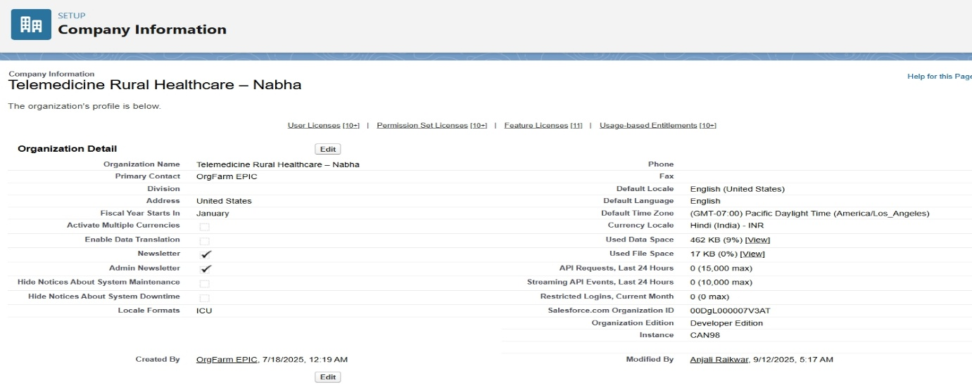

This setup ensures consistency across all users in the Org.

* **Business Hours & Holidays**

Path: Setup → Company Settings → Business Hours

- Default Business Hours: 9 AM – 6 PM (Monday – Saturday)

- Custom Business Hours:

* Teleconsultation Service Window: 7 AM – 9 PM
* Pharmacy Support: 9 AM – 8 PM

Holidays Configured:

* 15 August – Independence Day
* 26 January – Republic Day
* 2 October – Gandhi Jayanti
* 1 January – New Year

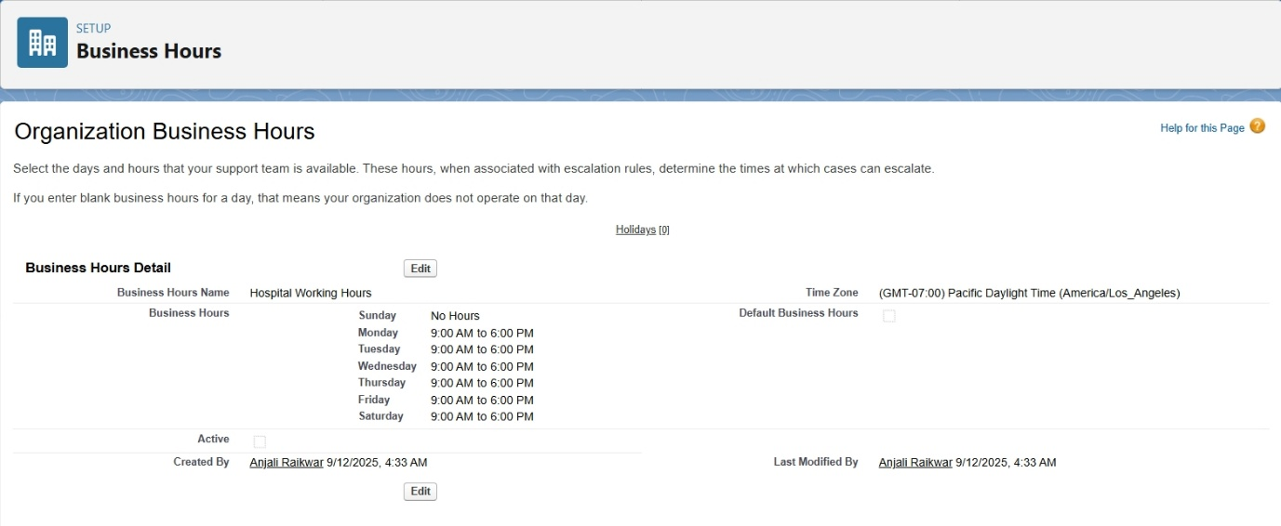

This ensures that SLA calculations, case escalations, and automated workflows respect working/non-working hours.

* **Fiscal Year Settings**

Path: Setup → Company Profile → Fiscal Year

- Fiscal Year set to “January” (Indian standard financial year).

- Standard fiscal year used (not custom).

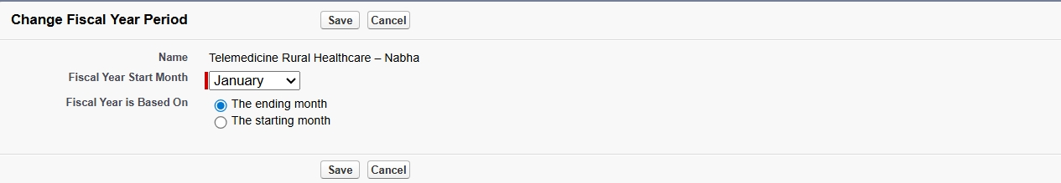

* **User Setup & Licenses**

We created multiple users to represent project stakeholders.

Users Created:

**1. Doctor User**

- Profile: Standard User

- License: Salesforce

- Role: Doctor

- Access: Can create/view patient records, schedule teleconsultations.

* + - **Name:** Dr. Amit Sharma
    - **Email:** dr.amitsharma@telemedicine.com
    - **Username:** doctor1@telemedicine.com
    - **Role:** Doctor
    - **User License:** **Salesforce**
    - **Profile:** Doctor Profile
    - **Business Hours:** Hospital Working Hours

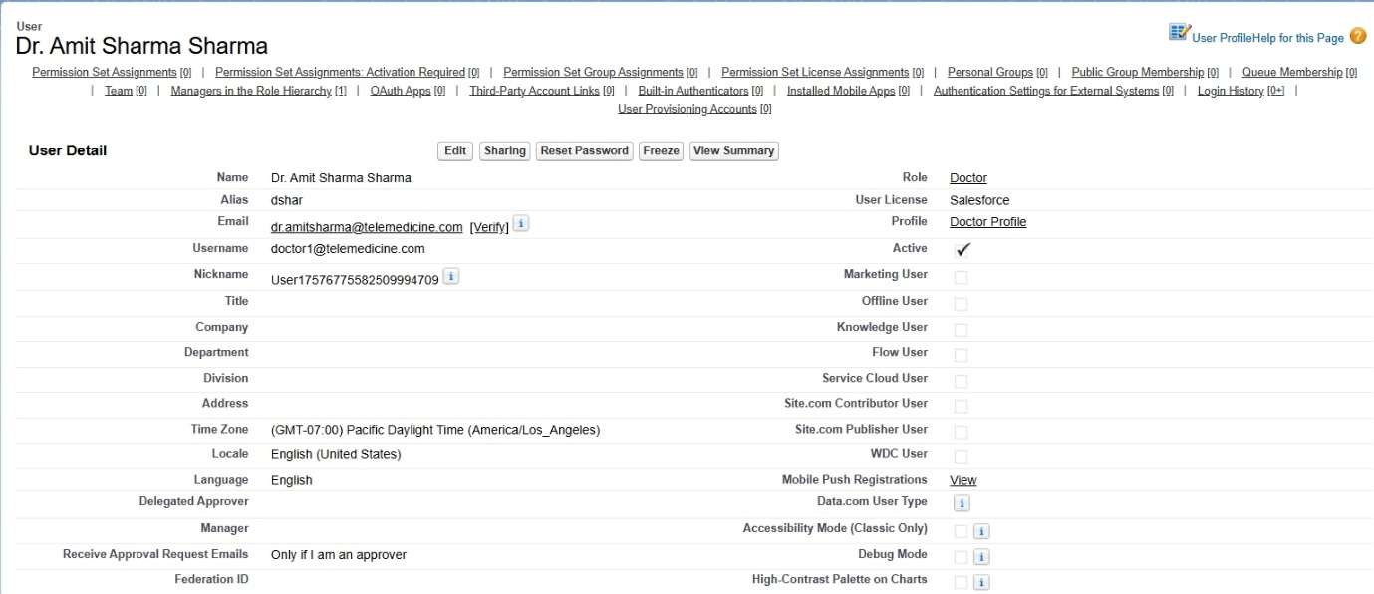

**2. Pharmacy Staff User**

- Profile: Standard User

- License: Salesforce Platform

- Role: Pharmacy Staff

- Access: Manage medicine inventory, update stock, issue medicines.

* + - **Name:** Neha Gupta
    - **Email:** neha.pharmacy@telemedicine.com
    - **Username:** pharmacy1@telemedicine.com
    - **Role:** Pharmacy Staff
    - **User License:** **Salesforce Platform**
    - **Profile:** Pharmacy Profile

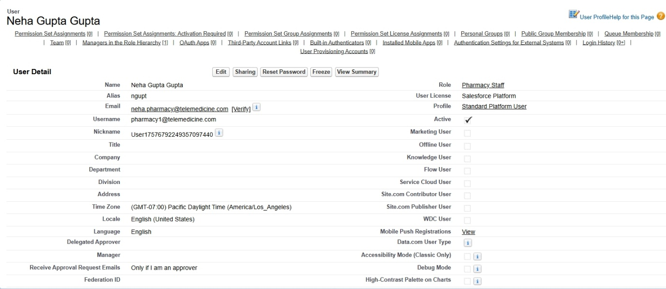

**3. Patient User**

- Profile: Customer Community User

- License: Customer Community

- Role: Patient

- Access: Limited portal access → view prescriptions, book consultations.

* + - **Name:** Rajesh Kumar
    - **Email:** rajesh.kumar@patient.com
    - **Username:** patient1@telemedicine.com
    - **Role:** Patient
    - **User License:** **Customer Community**
    - **Profile:** Patient Profile (restricted, only self-records visible)

**4. Admin User**

- Profile: System Administrator

- License: Salesforce

- Role: Admin

- Access: Full control of the Org, configurations, and monitoring.

* **Name:** Priya Singh
* **Email:** admin.priya@telemedicine.com
* **Username:** admin1@telemedicine.com
* **Role:** Hospital Admin
* **User License:** **Salesforce**
* **Profile:** System Administrator (full access)

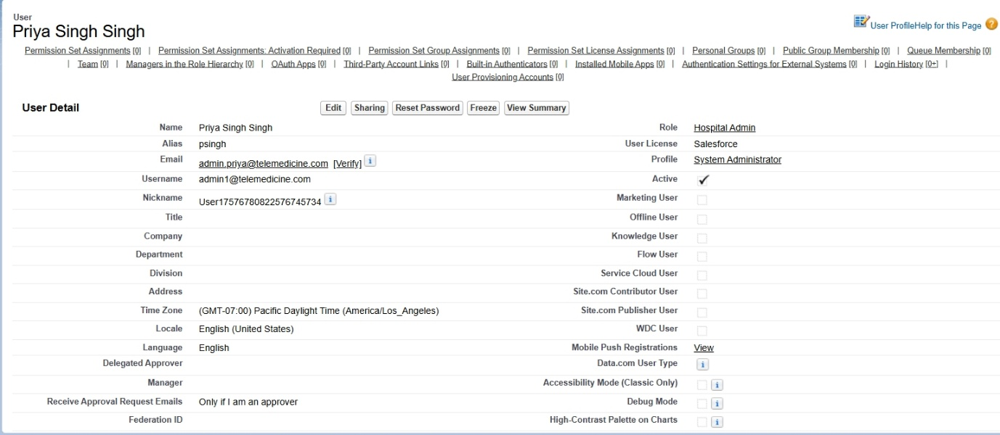

* **Profiles**

Profiles define baseline permissions for each type of user.

- Doctor Profile → Access to Patient, Appointment, Teleconsultation objects.

- Pharmacy Staff Profile → Access to Medicine Inventory, Order objects.

- Patient Profile → Limited access via community, can view only self-records.

- System Admin Profile → Full access.

* **Roles**

Roles help in data visibility (hierarchy-based).

- Admin / Hospital Admin (Top of hierarchy)

* Full org visibility.

- Doctor

* Can access assigned patient records.

- Pharmacy Staff

* + Can access medicine inventory and assigned orders.

- Patient

* + Only their own data (no hierarchy beyond).

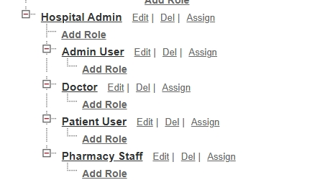

* **Permission Sets**

Permission sets give additional access without modifying profiles.

- Teleconsultation Access → Grants doctors permission to conduct video consultations.

- Analytics Access → Allows Health Dept Officers to view dashboards.

- Pharmacy Inventory Manager → Special permission to update stock levels.

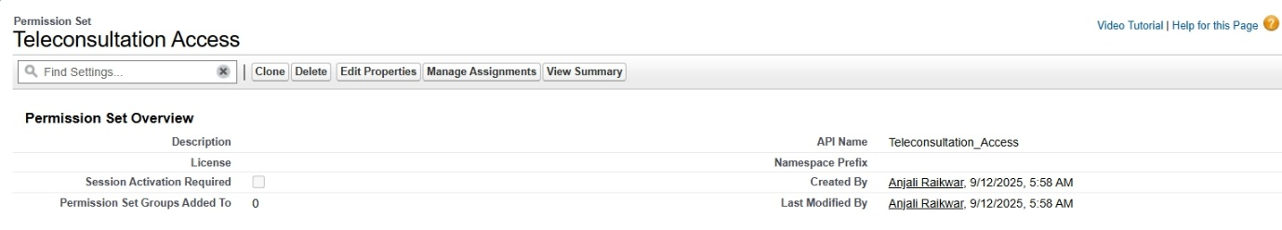

* **OWD**

Path: Setup → Sharing Settings

- Patient Records: Private (only Doctor + Patient can access).

- Teleconsultation Records: Private (only involved Doctor & Patient).

- Medicine Inventory: Public Read-Only (so staff can view, but only Pharmacy can edit).

- Hospital Announcements: Public Read/Write (all users can view/edit as needed).

* **Sharing Rules**

Created to extend access beyond OWD.

- Rule 1: Share all Patient Records with Doctor Role.

- Rule 2: Share Pharmacy Inventory (read-only) with Doctor Role so doctors can check stock before prescribing.

- Rule 3: Share Health Reports with Health Dept Officers for analysis.

* **Login Access Policies**

Admins can log in as any user for troubleshooting.

- Session Timeout: 2 hours.

- Trusted IP Ranges: Limited to India-based ranges to enhance security.

* **Dev Org Setup**

- A Developer Org is used for testing, LWC development, and configuration.

- Enabled Dev Hub for Salesforce DX (SFDX).

- Source-tracked development with VS Code + GitHub integration.

* **Sandbox Usage**

- Developer Sandbox: For coding and testing LWC components.

- Partial Copy Sandbox: For testing with sample patient & medicine records.

- Deployment between Sandbox and Production done using Change Sets.

* **Deployment Basics**

- Code & metadata stored in GitHub Repository.

- Deployment via:

* + Change Sets (Admin-friendly way).
  + SFDX CLI (Salesforce DX) for CI/CD pipeline simulation.

- Pre-deployment validations: Run unit tests, check profiles/permissions.

**Outcome of Phase 2**

With this setup:

- Users, roles, and permissions are clearly defined.

- Data access is secured via OWD & Sharing Rules.

- Business hours, holidays, and fiscal year ensure correct SLAs.

- Developer workflow is ready with Sandboxes, GitHub, and SFDX.